**LEBANESE AMERICAN UNIVERSITY**

**USAID – HIGHER EDUCATION SCHOLARSHIP PROGRAM**

**HES - Volunteering Program Verification Form**

This form is to be used to document volunteering hours. If a student volunteers for multiple organizations, a separate form must be used for each organization. **This form must be turned in by the 28th of each month, the latest.**

I certify that the scholar Maryam Ghader completed a total of 5 hours of service at InnovaThrive.

The hours were completed hours as per the below:

Hours # 0 (date) _2/12 – 6/12_ (initials of supervisor) __A.K.___

Hours # 0 (date) _9/12 – 13/12_ (initials of supervisor) __A.K.___

Hours # 5 date) _16/12 – 20/12 (initials of supervisor) __A.K.___

Hours # 0 date) _23/12 - 27/12 (initials of supervisor) __A.K.___

Brief description of the activities the scholar performed or participated in:

Maryam Ghader conducted research on "AI for Personalized Financial Planning," exploring how AI technologies can be applied to tailor financial strategies for individuals. The study examined various AI applications used in financial planning, such as algorithms for budgeting, investment recommendations, and risk management. It highlighted the advantages of AI, including enhanced personalization, better decision-making, and improved efficiency in managing finances.  
  
The research also addressed some of the disadvantages, such as data privacy concerns and the potential for bias in AI algorithms. Challenges like the need for accurate data and the risk of over-reliance on automated systems were also discussed. In conclusion, Maryam suggested recommendations for future research, focusing on improving AI transparency, enhancing data security, and developing more intuitive tools for personalized financial planning.

Written feedback about the scholar’s performance:

Maryam’s research on AI in personalized financial planning was detailed, addressing both advantages (personalization) and challenges (data privacy). Her suggestions for future research on AI transparency were well-founded.

Please rate the overall performance of the scholar at your organization:

|  |  |  |  |
| --- | --- | --- | --- |
|  | Mastery (5) | Proficient (3) | Emerging (1) |
| **Problem solver** | X |  |  |
| **Engaged & Committed** | X |  |  |
| **Open-minded & multicultural** | X |  |  |

Signature

& stamp

__________________________

_

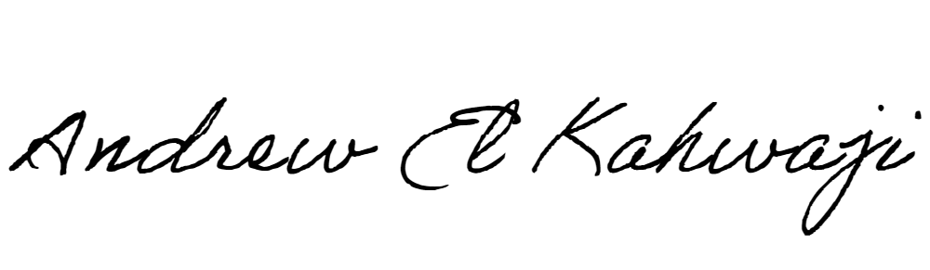

Printed Name _Andrew El Kahwaji_

Date __26/12/2024___

Email __andrew.lifesculptor.coo@gmail.com __

Phone __+961 71 914 378__